From the Chairman

**Dr. S .Cletus Babu**

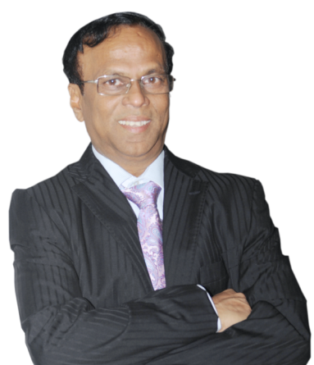

I take this opportunity to applaud you on your successful completion of your respective Programme. I am much delighted to see you all as - ‘An Engineering Professional’. Your four years of stay at Francis Xavier Engineering College has helped you identify your true potential and build your competence.

At this moment, dear Engineers, always be true to yourself ; no matter what the circumstances are - be principled, and be worthy of trust. Always carry the watch word of FX – Discipline – be disciplined at all walks of life.

Before closing my message, I would like to add 2 anecdotes which would make your life sparkle like diamonds and take you to greater heights.

1. Your attitude changes your reality.

2. Give respect & Get respect. Not the other way around.

With these words I bid adieu. Wherever you are placed keep empowering yourself with timely information and maintain the right tempo to win laurels to your profession.

May the Lord Almighty bestow His manifold blessing on you to keep achieving your passion and dream!

As you keep soaring high towards new horizons bring glory to your Alma mater and be connected with your Alma mater - Francis Xavier Engineering Alumni Association (FXAA).

I wish you the very best in your life!

From the Managing Director

**Mr. C. Arun Babu**

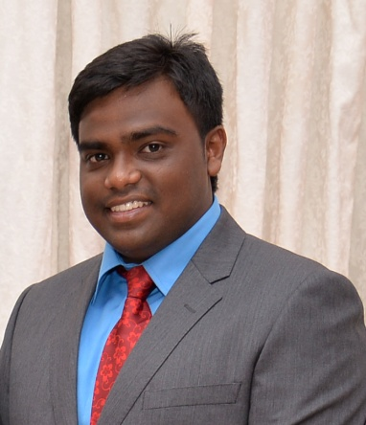

On this joyful occasion, I am pleased to see you all as a ‘Future Ready Professionals’ in your respective field of engineering.

Your active involvement and accomplishments in both curricular and non-curricular activities at FXEC have helped you stand tall amidst you counterparts. I acknowledge all your efforts during your stay in the campus.

As you enter into the corporate world face the challenges with confidence. Keep updating your knowledge, work with an enchanting vigour and always keep your spirits high.

Further, always give respect to noble ideas and demonstrate commitment and devotion to accomplish the task you are entrusted with. Increase in you the gravity of responsibility, be mature enough to take things in your stride and follow a pro-active strategy to bring fame to your profession and your Alma mater.

Wish you all the best!

From the General Manager (Finance)

**Mr. Ignatius Xavier**

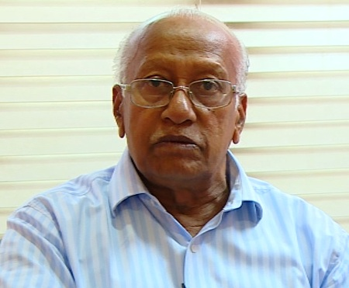

I deem it a great opportunity to congratulate you all on the successful completion of your Engineering Studies.

It is really a significant occasion because this institution has carved you as an engineering professional with sound technical knowledge and as a well disciplined citizen of the country with all ethics and moral values. From the recess of my heart, I appreciate you for having utilized every platform provided here to cultivate excellence and maintain the competitive edge to meet the industry requisites.

My dear young graduates, I wish you all to keep climbing up in your career ladder, whatever position you are in, work with integrity, brilliance and with enhanced team spirit and set a new benchmark for others to tag on and bring laurels to your Alma mater.

Wish you all to be at the winning spree at all times!

From the General Manager (Development)

**Prof. Dr.K.Jeyakumar**

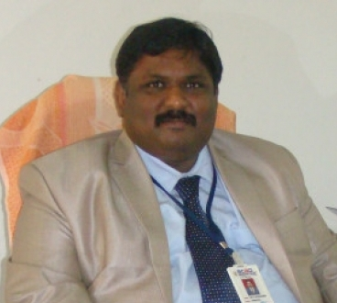

It’s my pleasure to greet you all on your successful completion of your Engineering Programme.

It is said that ‘*Success is the result of perfection, hard work, learning from failure, loyalty, and persistence’*. Dear professionals, it is your everyday thought, untiring desire to win, strong determination and well disciplined attitude at FXEC has helped you carve a niche for yourself. I would like to appreciate you for having utilized the infrastructure and resources to master yourself with the recent trends of technology.

At this moment, I wish you all success. Where ever you are employed, work with a great positive spirit and win glory to your profession. May God help you to keep adding feathers to your crown by your spectacular performance!

From the Professor(Academics) & Principal-in-charge

**Dr.D.C. Joy Winnie Wise**

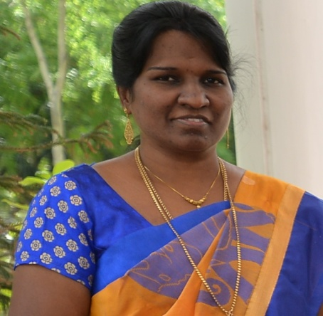I deem it a great opportunity to congratulate the students of the batch 2013-2017 for their brilliant academic feat in accomplishing their goal of becoming an engineering professional.

Thomas J. Stanley has said “*Before you can become a millionaire, you must learn to think like one”.* At this momentous occasion I feel proud that, Francis Xavier Engineering College right from day one has inspired you to learn to think the one to see you on this day as “a Professional”.

Always feel the pride of being an FXEC’ian. You are an extraordinary engineering professional because your engineering brilliance was fine-tuned here at FXEC.

Dear ones, wherever you are located, work with honesty and exhibit commitment towards excellence while carrying out research for future stability and solidity with the emerging trends of technology.

May God bless you!

From the Director, FXAA

**Mr. S. Krishnakumar**

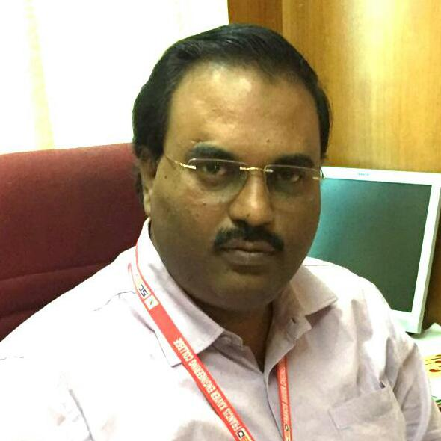

I take this opportunity to greet you all on this special occasion. I feel happy to see you as an Engineering professional with the required ethics and sky-scraping spirit; ready to contribute your intellectual resource to innovate and excel in your career.

I would like to appreciate you for having utilized every opportunity provided at this campus to empower you with all requisite skill to make yourself stand tall amidst your counterparts.

Thanks for extending your support for making your Alma Mater - this institution as one of the best institution in the south through your dedication and commitment. I feel very elated to see you all getting placed in MNCs holding great positions. Maintain a good rapport and win laurels to your Alma Mater by being loyal to your profession.

Wish you all the best.